Name: ___________________________
English II Semester I
Literary Analysis Paper Assignment
Purpose: To allow students to make appropriate connections between Maslow’s Hierarchy of Needs and a piece of literature, and to allow students to practice synthesizing information from at least two sources in their literary analysis writing.
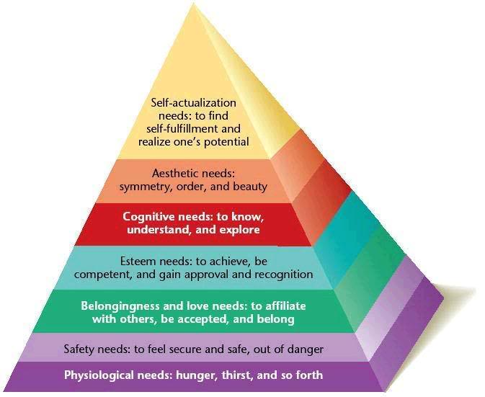
Task: Each student will demonstrate his/her understanding of Maslow’s Hierarchy of Needs, and specifically the first three levels (Physiological, Safety, Belongingness), by making connections between the level(s) and William Golding’s novel Lord of the Flies.
Students can select one of the following questions to answer to guide their paper’s argument:
- How do you attain and maintain a level of the pyramid?
- Why is it important to attain each of these levels in order?
- Other (with approval from teacher)
Consider the characters and how each one climbs and/or descends the pyramid. Also, consider why that happens. Changing relationships between characters? Events that occur? Personality flaws? You may choose to discuss one or more than one character in your paper. Also, be sure to mention all three of the first levels of the pyramid in your writing.
Requirements:
- Each student will use a minimum of two sources to develop the literary analysis paper, including the “Overview of Maslow” foundational article and Lord of the Flies. Additional sources are optional.
- Students must include an MLA formatted Works Cited page.
- Papers must be between two and three pages long, must contain parenthetical citations, and must follow MLA style.
- Use of prewriting, such as an outline, is encouraged.
- Each student’s prewriting, paper, Works Cited, and rubric will be stapled and turned in on the date papers are due.
- All papers must be submitted to Turnitin.com within one week of the paper due date.

